**Pre-Configured Raid Messages StreamerBot Extension**

**Created by Vengey**

**[** [**https://twitter.com/ItsVengey**](https://twitter.com/ItsVengey) **|** [**https://www.twitch.tv/itsvengey**](https://www.twitch.tv/itsvengey) **|** [**https://vengey.carrd.co/**](https://vengey.carrd.co/) **]**

**How to Import into StreamerBot…**

**STEP 1: *Copy this LONG string***



**STEP 2**: ***Click Import in Streamerbot***

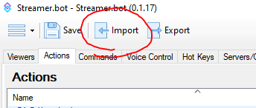

**STEP 3**: ***Paste the code into “Import String”, an action and command will show up, then hit “Import”***

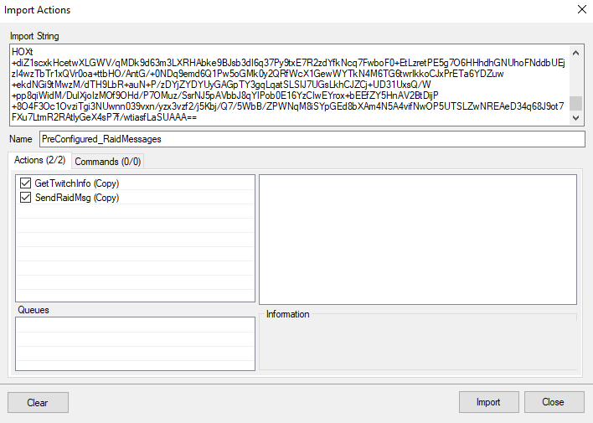

**STEP 4**: ***Go to your Actions tab; look for an action called “SendRaidMsg” and double click the sub-action labeled “Execute Code”, it should be the very last sub-action listed here***

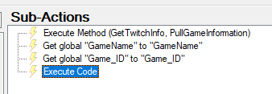

**STEP 5**: ***Follow the instructions in the green comments. You can setup as many case statements as you need for as many games you want to setup raid messages for! There’s a default raid message for just general use you can edit as well!***

***Here’s an example of what your final file could look like!***

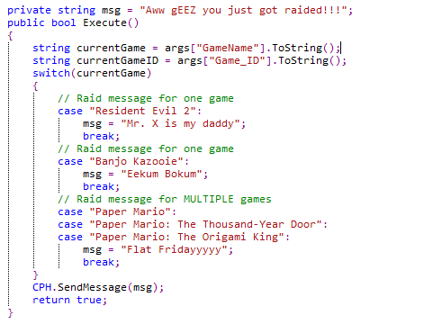

***To input a valid game name, just copy and paste EXACTLY what twitch suggests when you enter one on their site***

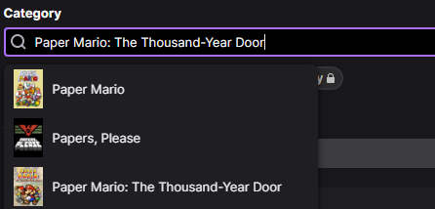

**STEP 6**: ***When you are done, make sure you hit “Save and Compile”***

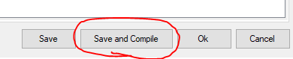

**STEP 7:** ***Wire this action up!***

You can wire this up however you would like

You could setup an !raid command to call this action

You could setup a hotkey to call this action

OR… my personal preferred method is to wire it up via the “Sending Raid” > “Start” event so that it automatically sends the message as soon as the raid has been initiated!

